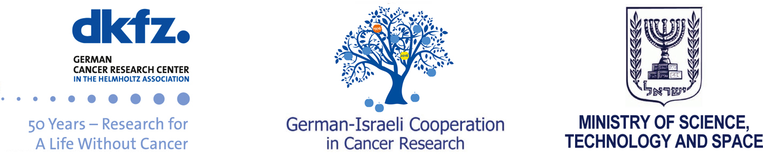

8th German-Israeli – Cancer Research School

Cancer Immunotherapy

Application Form
Location: A Kibbuz near Jerusalem, Israel
Time: November 20-24, 2016 (November 20 and 24 are travel days)

Name (Last, First):

E-mail-address:

Degree (Post-Doc; PhD Student; MSc Student – or equivalent):

Gender:

Thesis Title:

Thesis adviser / PI:

Is PI funded by the DKFZ-MOST cooperation? Yes / No

Institution / Department / City:

Why do you like to take part in the “German-Israeli Cancer Research School”?

What is your interest in cancer research?

Relevance of your research to cancer:

Please add your C.V. (including a picture, jpeg format, 300 dpi) and list of publications/abstracts to this filled-in form. Further we require an abstract of your intended poster for the school, of about 1700 characters (see attached sample).

